
Delhi Public School, Howrah
PT2 EXAMINATION (2024 -25)
Class-XI
Care must be taken not to write anything on the question paper. All the questions must be attempted in the correct sequence.
SUBJECT: GEOGRAPHY PRACTICAL (CODE- 029)
TIME ALLOWED- 3 HOURS F.M.-30
__________________________________________________________________________________________________________
GENERAL INSTRUCTIONS-
- There are 7 questions in the question paper. All questions are compulsory.
- Map Projection should be neatly presented and labeled.
 | SECTION A
1. | Picture Study:-  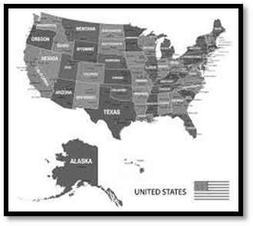  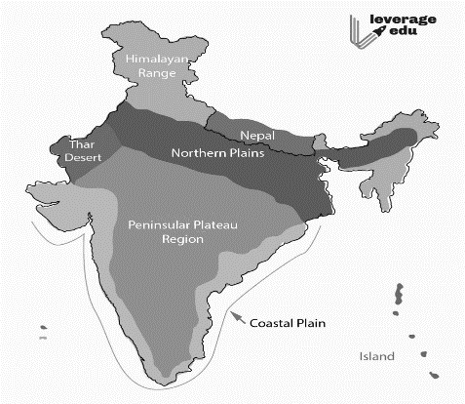  Identify the types of map and differentiate between them. | 2
2. | Find out the longitudes and latitudes of the given places:-  - Algeria  b)Chad  c)Tanzania  d)Niger | 2
3. | Scale :-  (i)Convert the given Representative Fraction (R.F.) into Statement of Scale in the System of Measurement shown in parentheses:  1 : 31680 (into furlongs)  (ii)Convert the given Statement of Scale into Representative Fraction (R.F.):  1 inch represents 1 yard | 2
4. | Time Numericals:-  - What is the time and day at a certain place on 40 °E longitude when it is 5.30 am on Friday at a place 90°E longitude?  - The World Heavy Weight Boxing Championship fight between Mohammed Ali and Joe Frazier was held in New York (75°W) at 8.30: p.m. on Wednesday. At what time can it be listened to in New Delhi(77°E)? | 4  (2+2)
5. | Linear scale:-  Construct a Linear scale diagram, when the given R. F. is 1: 85,000 and read the distances in kilometre and metre. | 4
6. | Map Projection:-  A. Prepare graticule for a Cylindrical Equal Area Projection for the world when R.F. is 1: 150,000,000 and the interval is 15°.  B. Draw a Mercator Projection for the world map when the R.F. is 1:400,000,000 and the interval between the latitude and longitude is 20°. | 8  4+4
7. | Why is there a need for Map Projection, When representing the Earth surface on a flat area? | 3
 | SECTION B
 | Practical Notebook and Viva-Voce | 5

Map for question No.1
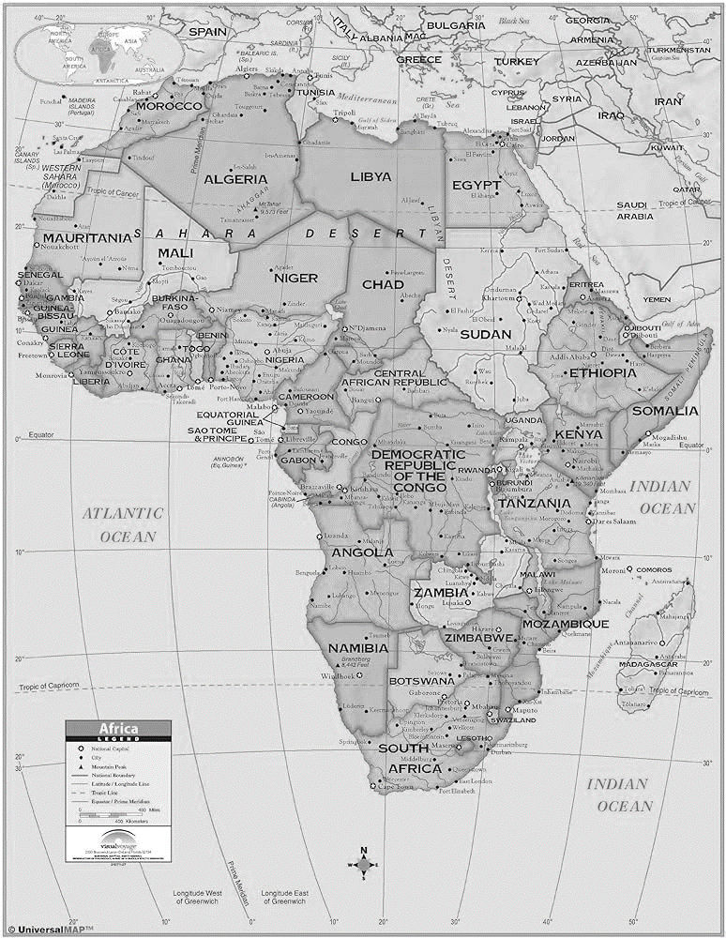

Table for Mercator’s Projection

Latitude | Distance from the equator | Latitude | Distance from the equator
5° | r x 0.087 | 45° | r x 0.880
10° | r x 0.175 | 50° | r x 1.011
15° | r x 0.265 | 55° | r x 1.153
20° | r x 0.356 | 60° | r x 1.317
25° | r x 0.540 | 65° | r x 1.505
30° | r x 0.549 | 70° | r x 1.736
35° | r x 0.650 | 75° | r x 2.025
40° | r x 0.763 | 80° | r x 2.436

